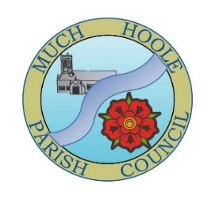 | Minutes of the Much Hoole Parish Council Extraordinary meeting held on Monday 21st July 2025 at 7.00pm at The Venue, Hoole Village Memorial Hall, Much Hoole.

Present: Cllrs K. Hayes (Chair), R. Lea, A. Taylor, E. Houghton, P. Cocker, E. Jackson and Clerk Miss A. Evans.

- Apologies for Absence
Apologies were received from Cllr T. Hewitt

- Declaration of Interests and Dispensations:
There were no declarations of interest.

- Co-option
The council considered applications for co-option to fill one vacancy. Two applications were initially received, with one later being withdrawn. The one applicant was present and invited to attend the meeting. Councillors and the Clerk introduced themselves, and the applicant was asked a series of questions to check suitability for the role. After discussion and a vote, it was resolved that Mr Paul Fox was duly co-opted as Parish Councillor. This was proposed by Cllr A. Taylor, seconded by Cllr E. Houghton and unanimously agreed.

- Signing of Declaration of Acceptance of Office (if applicable)
It was agreed that the signing of the Declaration of Acceptance of Office be deferred as an opening agenda item at the September Parish Council meeting. The Declaration of interests form was completed and signed.

- Close of meeting
The meeting was closed at 7:20pm

